Cold Chain Shipment Silent Failure EDA (Code & Output)
8,000 shipments, 23 features, binary target silent_failure.

Setup

import numpy as np
import pandas as pd
import matplotlib.pyplot as plt
import seaborn as sns
from scipy.stats import zscore
%matplotlib inline
sns.set_style("whitegrid")
PALETTE = ["#3E6E8E", "#C0524D"] # blue = non-failure (0), red = silent failure (1)
sns.set_palette(PALETTE)
plt.rcParams["figure.dpi"] = 110
plt.rcParams["axes.titlesize"] = 13
plt.rcParams["axes.titleweight"] = "medium"
pd.set_option("display.max_columns", 30)
pd.set_option("display.width", 120)

1. Data Loading & Inspection
We load the raw CSV and take a first look at its shape, column names, and a sample of records.
df = pd.read_csv("shipment-sensor-dataset.csv")
print(f"Shape: {df.shape[0]} rows x {df.shape[1]} columns")
df.head()
Shape: 8000 rows x 24 columns
shipment_id transit_days door_opens temp_mean_c temp_max_c temp_min_c temp_std_c temp_recovery_rate rh_mean \
0 SHP000000 4.515 21 9.599 10.913 7.960 1.290 0.5629 0.5914
1 SHP000001 1.696 5 2.411 3.261 2.030 0.614 0.4452 0.4216
2 SHP000002 1.319 2 3.261 4.310 3.135 0.443 0.4003 0.4410
3 SHP000003 6.495 19 5.188 7.545 4.875 1.986 0.5774 0.4522
4 SHP000004 1.795 4 3.520 3.713 2.680 0.799 0.2883 0.4590
rh_std rh_max package_type product_volume_l fill_ratio carrier_id origin_zone dest_zone leg_count \
0 0.0764 0.6404 2 16.19 0.8300 10 0 0 1
1 0.0251 0.4670 2 7.31 0.7562 6 2 0 1
2 0.0399 0.5962 0 10.21 0.7271 0 5 0 2
3 0.0597 0.9900 1 0.87 0.8380 7 1 5 1
4 0.0531 0.5462 0 11.50 0.6914 4 0 5 2
sensor_gap_hours vibration_index feature_x1 feature_x2 feature_x3 silent_failure
0 1.005 2.2727 -2.2325 -0.5249 0 0
1 0.541 2.1837 2.6035 -0.6972 0 0
2 0.395 2.5449 0.4678 0.7930 0 0
3 1.371 1.3480 0.5615 0.4204 0 0
4 0.089 0.5495 -1.5750 0.8817 0 0
df.info()
<class 'pandas.DataFrame'>
RangeIndex: 8000 entries, 0 to 7999
Data columns (total 24 columns):
# Column Non-Null Count Dtype
--- ------ -------------- -----
0 shipment_id 8000 non-null str
1 transit_days 8000 non-null float64
2 door_opens 8000 non-null int64
3 temp_mean_c 8000 non-null float64
4 temp_max_c 8000 non-null float64
5 temp_min_c 8000 non-null float64
6 temp_std_c 8000 non-null float64
7 temp_recovery_rate 7936 non-null float64
8 rh_mean 8000 non-null float64
9 rh_std 8000 non-null float64
10 rh_max 7666 non-null float64
11 package_type 8000 non-null int64
12 product_volume_l 8000 non-null float64
13 fill_ratio 8000 non-null float64
14 carrier_id 8000 non-null int64
15 origin_zone 8000 non-null int64
16 dest_zone 8000 non-null int64
17 leg_count 8000 non-null int64
18 sensor_gap_hours 8000 non-null float64
19 vibration_index 8000 non-null float64
20 feature_x1 8000 non-null float64
21 feature_x2 8000 non-null float64
22 feature_x3 8000 non-null int64
23 silent_failure 8000 non-null int64
dtypes: float64(15), int64(8), str(1)
memory usage: 1.5 MB
Note: 8,000 records, 24 columns — a unique shipment_id, 16 continuous sensor features, 6 categorical/count features, and the target.

2. Data Type Validation
We confirm that shipment_id is a genuine unique identifier (safe to drop for modeling) and separate the remaining columns into continuous vs. categorical/count groups based on cardinality and domain meaning.
print("shipment_id unique:", df["shipment_id"].is_unique)
categorical_like = ["package_type", "carrier_id", "origin_zone", "dest_zone",
"leg_count", "feature_x3", "silent_failure"]
continuous_like = [c for c in df.columns if c not in categorical_like + ["shipment_id"]]
print(f"\nCategorical / count columns ({len(categorical_like)}): {categorical_like}")
print(f"\nContinuous columns ({len(continuous_like)}): {continuous_like}")
for c in categorical_like:
print(f"{c:15s} -> {sorted(df[c].unique())}")
shipment_id unique: True
Categorical / count columns (7): ['package_type', 'carrier_id', 'origin_zone', 'dest_zone', 'leg_count', 'feature_x3', 'silent_failure']
Continuous columns (16): ['transit_days', 'door_opens', 'temp_mean_c', 'temp_max_c', 'temp_min_c', 'temp_std_c', 'temp_recovery_rate', 'rh_mean', 'rh_std', 'rh_max', 'product_volume_l', 'fill_ratio', 'sensor_gap_hours', 'vibration_index', 'feature_x1', 'feature_x2']
package_type -> [np.int64(0), np.int64(1), np.int64(2)]
carrier_id -> [np.int64(0), np.int64(1), np.int64(2), np.int64(3), np.int64(4), np.int64(5), np.int64(6), np.int64(7), np.int64(8), np.int64(9), np.int64(10), np.int64(11)]
origin_zone -> [np.int64(0), np.int64(1), np.int64(2), np.int64(3), np.int64(4), np.int64(5)]
dest_zone -> [np.int64(0), np.int64(1), np.int64(2), np.int64(3), np.int64(4), np.int64(5)]
leg_count -> [np.int64(1), np.int64(2), np.int64(3)]
feature_x3 -> [np.int64(0), np.int64(1)]
silent_failure -> [np.int64(0), np.int64(1)]
Note: shipment_id is unique for every row and is dropped from analysis; package_type, carrier_id, origin_zone, dest_zone, leg_count, feature_x3 are treated as categorical.

3. Missing-Value Analysis
Next we quantify missingness column by column.
missing = df.isna().sum()
missing = missing[missing > 0].sort_values(ascending=False)
missing_pct = (missing / len(df) * 100).round(2)
missing_table = pd.DataFrame({"missing_count": missing, "missing_pct": missing_pct})
missing_table
missing_count missing_pct
rh_max 334 4.18
temp_recovery_rate 64 0.80
fig, ax = plt.subplots(figsize=(7, 4))
bars = ax.barh(missing_table.index[::-1], missing_table["missing_count"][::-1],
color="#6b6b6b")
for bar, (cnt, pct) in zip(bars, missing_table[["missing_count", "missing_pct"]].values[::-1]):
ax.text(bar.get_width() + 5, bar.get_y() + bar.get_height() / 2,
f"{int(cnt)} ({pct}%)", va="center", fontsize=10)
ax.set_xlabel("Missing count")
ax.set_title("Missing Values by Column")
ax.set_xlim(0, missing_table["missing_count"].max() * 1.25)
plt.tight_layout()
plt.savefig("figures/01_missing_values.png", bbox_inches="tight")
plt.show()
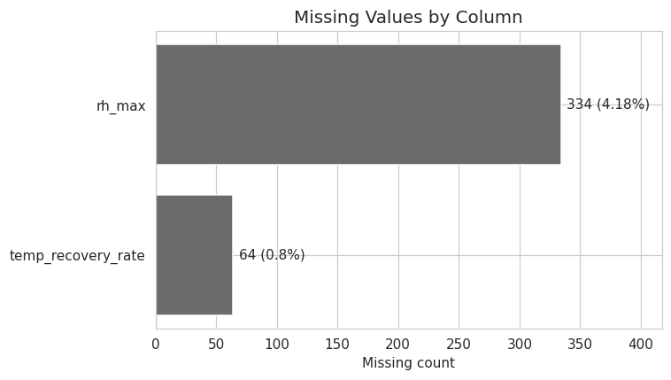
Note: Only rh_max (4.2%) and temp_recovery_rate (0.8%) have missing values — both imputed with class-conditional medians rather than dropped.

4. Missing-Value Treatment
A naive column-wide median fill would pull every imputed value toward the overall median, diluting the very association with silent_failure that makes rh_max important. Instead we use class-conditional median imputation: missing values in the failure class are filled with the median computed only from failure rows, and likewise for the non-failure class. This preserves the between-class gap while still producing a sensible, low-bias fill value.
df_clean = df.copy()
for col in ["rh_max", "temp_recovery_rate"]:
class_medians = df_clean.groupby("silent_failure")[col].transform("median")
n_before = df_clean[col].isna().sum()
df_clean[col] = df_clean[col].fillna(class_medians)
print(f"{col}: imputed {n_before} values using class-conditional medians "
f"(0: {df_clean.groupby('silent_failure')[col].median()[0]:.4f}, "
f"1: {df_clean.groupby('silent_failure')[col].median()[1]:.4f})")
print("\nRemaining missing values:", df_clean.isna().sum().sum())
rh_max: imputed 334 values using class-conditional medians (0: 0.5702, 1: 0.7013)
temp_recovery_rate: imputed 64 values using class-conditional medians (0: 0.4380, 1: 0.4726)
Remaining missing values: 0

5. Duplicate & Range Consistency Checks
We check for fully duplicated rows and verify that bounded features (rates, ratios) fall within their physically valid ranges.
print("Fully duplicated rows:", df_clean.duplicated().sum())
print("Duplicated shipment_id:", df_clean['shipment_id'].duplicated().sum())
range_checks = pd.DataFrame({
"min": df_clean[["fill_ratio", "rh_mean", "rh_std", "rh_max", "temp_recovery_rate"]].min(),
"max": df_clean[["fill_ratio", "rh_mean", "rh_std", "rh_max", "temp_recovery_rate"]].max(),
})
range_checks
Fully duplicated rows: 0
Duplicated shipment_id: 0
min max
fill_ratio 0.1855 1.0000
rh_mean 0.2191 0.9076
rh_std 0.0001 0.2940
rh_max 0.2396 0.9900
temp_recovery_rate 0.0103 0.8925
Note: No duplicate rows or IDs; all bounded fields (fill_ratio, humidity) fall within valid [0,1]-ish ranges.

6. Descriptive Statistics
Summary statistics for the core numerical features.
core_numeric = ["transit_days", "door_opens", "temp_mean_c", "temp_max_c", "temp_min_c",
"temp_std_c", "temp_recovery_rate", "rh_mean", "rh_std", "rh_max",
"product_volume_l", "fill_ratio", "sensor_gap_hours", "vibration_index"]
df_clean[core_numeric].describe().T.round(3)
count mean std min 25% 50% 75% max
transit_days 8000.0 3.998 2.957 0.500 1.821 3.137 4.783 17.332
door_opens 8000.0 8.803 6.171 0.000 4.000 7.000 13.000 36.000
temp_mean_c 8000.0 4.294 1.720 -1.672 3.230 4.117 5.207 12.146
temp_max_c 8000.0 5.823 2.458 -1.383 4.180 5.277 7.111 19.377
temp_min_c 8000.0 3.492 1.734 -4.331 2.434 3.478 4.409 12.111
temp_std_c 8000.0 1.269 0.698 0.001 0.706 1.116 1.723 4.224
temp_recovery_rate 8000.0 0.443 0.139 0.010 0.348 0.443 0.537 0.892
rh_mean 8000.0 0.514 0.100 0.219 0.445 0.503 0.574 0.908
rh_std 8000.0 0.068 0.037 0.000 0.041 0.061 0.090 0.294
rh_max 8000.0 0.620 0.144 0.240 0.517 0.589 0.702 0.990
product_volume_l 8000.0 12.033 3.931 0.080 9.400 12.040 14.690 29.280
fill_ratio 8000.0 0.717 0.145 0.186 0.620 0.720 0.819 1.000
sensor_gap_hours 8000.0 0.790 0.793 0.000 0.225 0.549 1.091 6.000
vibration_index 8000.0 1.835 0.931 0.004 1.173 1.779 2.425 5.817

7. Target Class Distribution
counts = df_clean["silent_failure"].value_counts().sort_index()
pct = (counts / counts.sum() * 100).round(1)
fig, ax = plt.subplots(figsize=(6, 5))
bars = ax.bar(["Non-failure (0)", "Silent failure (1)"], counts.values, color=PALETTE)
for bar, c, p in zip(bars, counts.values, pct.values):
ax.text(bar.get_x() + bar.get_width() / 2, bar.get_height() + 60,
f"{c}\n({p}%)", ha="center", fontsize=11)
ax.set_ylabel("Number of shipments")
ax.set_title("Target Class Distribution")
ax.set_ylim(0, counts.max() * 1.15)
plt.tight_layout()
plt.savefig("figures/02_target_balance.png", bbox_inches="tight")
plt.show()
print(counts)
print(pct)
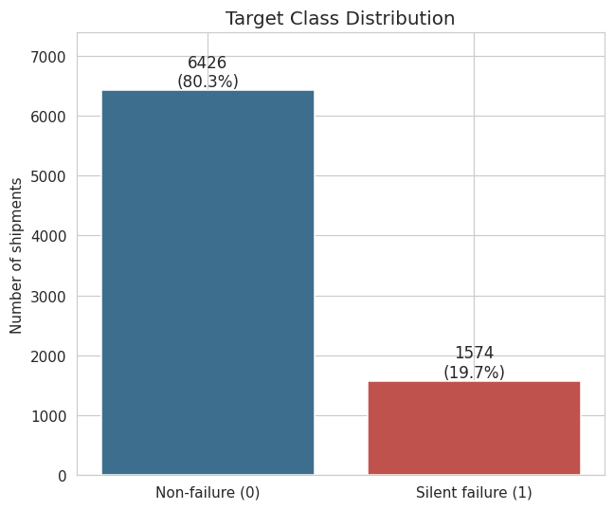
silent_failure
0 6426
1 1574
Name: count, dtype: int64
silent_failure
0 80.3
1 19.7
Name: count, dtype: float64
Note: Target is imbalanced — 80.3% non-failure vs. 19.7% silent failure (1,574 records). Use stratified sampling / class weighting downstream.

8. Univariate Analysis
Distributions of the key numerical features, irrespective of the target class.
univariate_cols = ["transit_days", "door_opens", "temp_mean_c",
"temp_std_c", "rh_mean", "sensor_gap_hours"]
fig, axes = plt.subplots(2, 3, figsize=(15, 8))
fig.suptitle("Univariate Distributions of Key Numerical Features", fontsize=15)
for ax, col in zip(axes.flat, univariate_cols):
sns.histplot(df_clean[col], kde=True, ax=ax, color="#4C72A8", edgecolor="white")
ax.set_title(col)
ax.set_xlabel("")
plt.tight_layout()
plt.savefig("figures/03_univariate_grid.png", bbox_inches="tight")
plt.show()
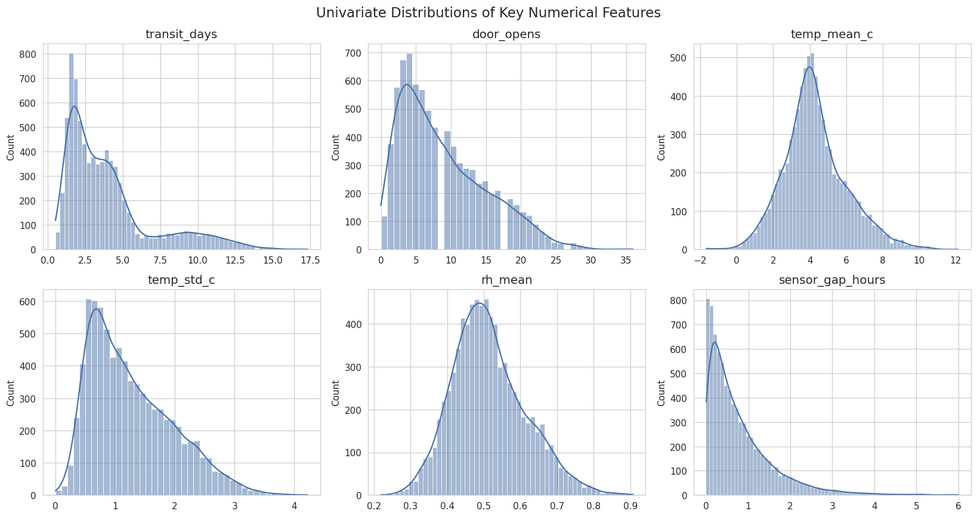
skew_table = df_clean[core_numeric].skew().sort_values(ascending=False).round(3)
skew_table.to_frame("skewness")
skewness
sensor_gap_hours 2.009
transit_days 1.490
temp_max_c 0.972
door_opens 0.829
rh_std 0.818
temp_std_c 0.790
rh_max 0.678
rh_mean 0.496
temp_mean_c 0.493
vibration_index 0.407
temp_min_c 0.202
product_volume_l -0.001
temp_recovery_rate -0.004
fill_ratio -0.175
Note: All core features are right-skewed (Poisson-like); none need normality assumptions but linear models would benefit from a log1p transform.

9. Bivariate Analysis: Features vs. Target
We compare the distribution of key features across the two target classes using boxplots, and compute class-conditional means.
bivariate_cols = ["temp_mean_c", "temp_range_c", "transit_days", "door_opens"]
# temp_range_c is created early here so it can be included in this comparison;
# the full feature-engineering step (Section 10) documents it formally.
df_clean["temp_range_c"] = df_clean["temp_max_c"] - df_clean["temp_min_c"]
fig, axes = plt.subplots(1, 4, figsize=(18, 5))
fig.suptitle("Bivariate Comparison of Key Features Across Target Classes", fontsize=15)
for ax, col in zip(axes, bivariate_cols):
sns.boxplot(data=df_clean, x="silent_failure", y=col, hue="silent_failure",
palette=PALETTE, legend=False, ax=ax)
ax.set_title(col)
plt.tight_layout()
plt.savefig("figures/04_bivariate_boxplots.png", bbox_inches="tight")
plt.show()
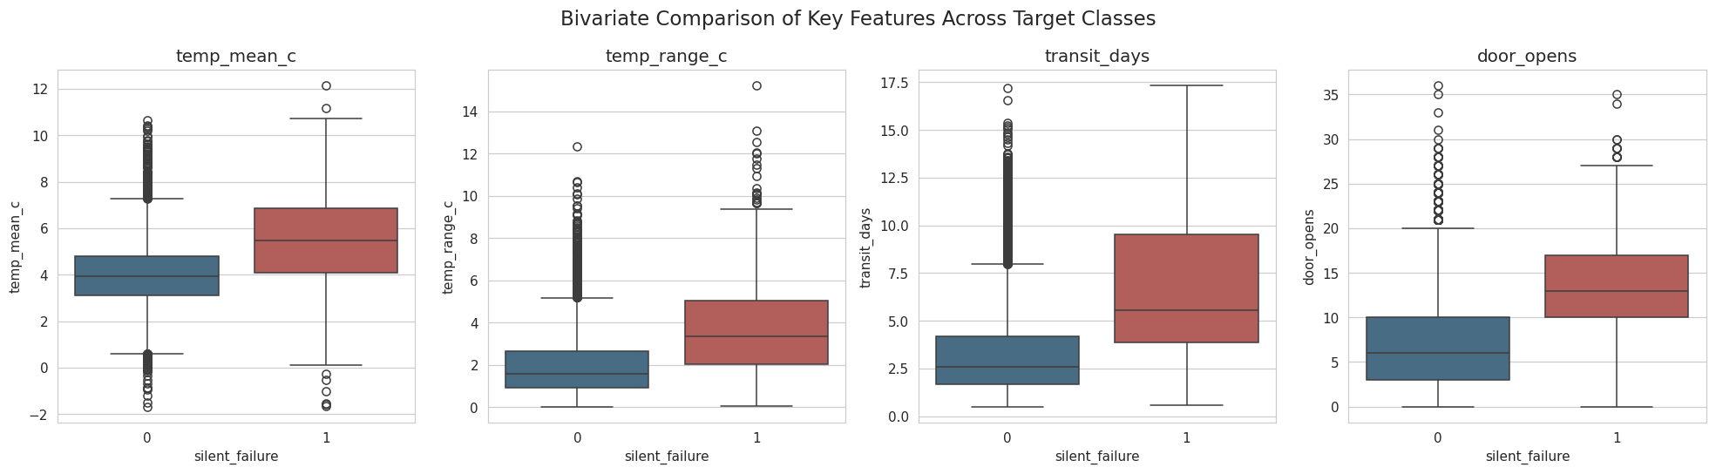
group_means = df_clean.groupby("silent_failure")[
["transit_days", "door_opens", "temp_mean_c", "temp_range_c"]
].mean().round(2)
group_means.index = ["Non-failure (0)", "Silent failure (1)"]
group_means
transit_days door_opens temp_mean_c temp_range_c
Non-failure (0) 3.34 7.60 4.01 1.99
Silent failure (1) 6.70 13.72 5.45 3.73
Note: Failures average 6.70 transit days vs 3.34, 13.72 door opens vs 7.60, 5.45°C vs 4.01°C mean temp, 3.73°C vs 2.00°C temp range — higher on every axis.

10. Categorical Feature Analysis
We compute the silent-failure rate within each level of the categorical / routing features to see which (if any) carry signal.
def failure_rate_table(frame, col):
t = frame.groupby(col)["silent_failure"].agg(["mean", "count"])
t["mean"] = (t["mean"] * 100).round(2)
return t.rename(columns={"mean": "failure_rate_pct"})
for col in ["leg_count", "package_type", "carrier_id", "origin_zone", "dest_zone", "feature_x3"]:
print(f"--- {col} ---")
print(failure_rate_table(df_clean, col))
print()
--- leg_count ---
failure_rate_pct count
leg_count
1 14.64 3580
2 24.45 3059
3 22.19 1361
--- package_type ---
failure_rate_pct count
package_type
0 17.51 4033
1 23.56 2415
2 19.27 1552
--- carrier_id ---
failure_rate_pct count
carrier_id
0 21.71 668
1 22.63 685
2 17.94 641
3 20.56 647
4 21.39 692
5 19.76 668
6 18.38 653
7 20.28 651
8 16.69 611
9 19.26 727
10 18.09 669
11 19.04 688
--- origin_zone ---
failure_rate_pct count
origin_zone
0 20.28 1410
1 20.35 1332
2 18.24 1321
3 21.29 1329
4 18.57 1319
5 19.24 1289
--- dest_zone ---
failure_rate_pct count
dest_zone
0 21.00 1386
1 19.01 1278
2 20.78 1386
3 18.58 1292
4 18.59 1334
5 19.94 1324
--- feature_x3 ---
failure_rate_pct count
feature_x3
0 19.92 5637
1 19.09 2363
fig, axes = plt.subplots(1, 2, figsize=(12, 5))
rate_leg = df_clean.groupby("leg_count")["silent_failure"].mean() * 100
axes[0].bar(rate_leg.index.astype(str), rate_leg.values, color="#3E6E8E")
for i, v in enumerate(rate_leg.values):
axes[0].text(i, v + 0.4, f"{v:.1f}%", ha="center")
axes[0].set_title("Silent Failure Rate by Leg Count")
axes[0].set_xlabel("leg_count")
axes[0].set_ylabel("Failure rate (%)")
rate_pkg = df_clean.groupby("package_type")["silent_failure"].mean() * 100
axes[1].bar(rate_pkg.index.astype(str), rate_pkg.values, color="#C0524D")
for i, v in enumerate(rate_pkg.values):
axes[1].text(i, v + 0.4, f"{v:.1f}%", ha="center")
axes[1].set_title("Silent Failure Rate by Package Type")
axes[1].set_xlabel("package_type")
plt.tight_layout()
plt.savefig("figures/05_categorical_failure_rate.png", bbox_inches="tight")
plt.show()
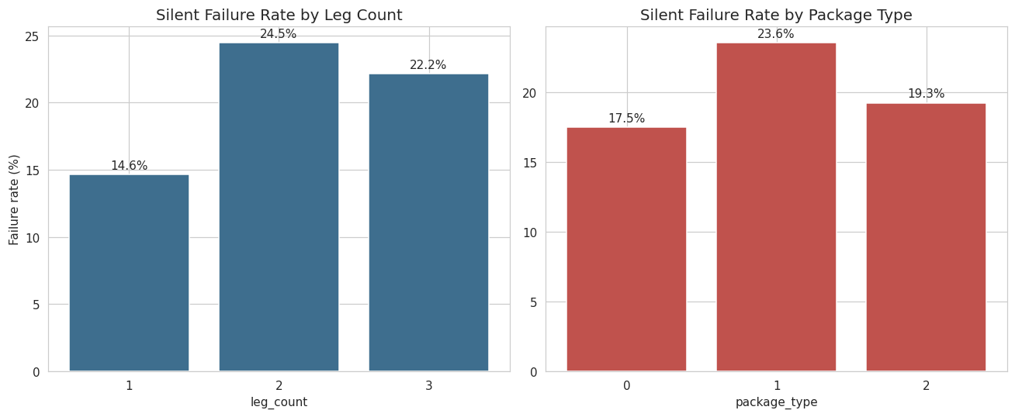
Note: leg_count (14.6%/24.5%/22.2%) and package_type (17.5%/23.6%/19.3%) show real spread; carrier_id, zones, feature_x3 are near-flat (~17-23%) and carry little signal.

11. Feature Engineering
Feature | Formula | Rationale
temp_range_c | temp_max_c - temp_min_c | Spread of temperature swing during transit
door_open_rate | door_opens / transit_days | Handling frequency, normalized by duration
vibration_rate | vibration_index / transit_days | Mechanical stress, normalized by duration
rh_range | rh_max - rh_mean | Humidity spread (no rh_min is recorded, so this is a one-sided proxy for volatility around the mean)
excursion_intensity | 0.4 * z(temp_range_c) + 0.6 * z(sensor_gap_hours) | Standardized, weighted combination capturing both the size of a temperature swing and how long the shipment went unmonitored (a long sensor gap makes any excursion during that window "silent" by definition)
eng = df_clean.copy()
eng["temp_range_c"] = eng["temp_max_c"] - eng["temp_min_c"]
eng["door_open_rate"] = eng["door_opens"] / eng["transit_days"]
eng["vibration_rate"] = eng["vibration_index"] / eng["transit_days"]
eng["rh_range"] = eng["rh_max"] - eng["rh_mean"]
z_temp_range = zscore(eng["temp_range_c"])
z_gap = zscore(eng["sensor_gap_hours"])
eng["excursion_intensity"] = 0.4 * z_temp_range + 0.6 * z_gap
new_features = ["temp_range_c", "door_open_rate", "vibration_rate",
"rh_range", "excursion_intensity"]
eng[new_features].describe().T.round(3)
count mean std min 25% 50% 75% max
temp_range_c 8000.0 2.331 1.784 0.027 1.039 1.830 3.116 15.220
door_open_rate 8000.0 2.570 1.859 0.000 1.326 2.118 3.376 54.000
vibration_rate 8000.0 0.721 0.652 0.001 0.270 0.526 0.974 8.278
rh_range 8000.0 0.106 0.090 -0.216 0.040 0.084 0.151 0.538
excursion_intensity 8000.0 0.000 0.715 -1.099 -0.520 -0.157 0.355 4.928
Note: Compare raw vs. engineered-feature correlation with target to check the transform actually adds signal.
comparisons = pd.DataFrame({
"raw_feature": ["door_opens", "vibration_index", "sensor_gap_hours"],
"raw_corr": [eng["door_opens"].corr(eng["silent_failure"]),
eng["vibration_index"].corr(eng["silent_failure"]),
eng["sensor_gap_hours"].corr(eng["silent_failure"])],
"engineered_feature": ["door_open_rate", "vibration_rate", "excursion_intensity"],
"engineered_corr": [eng["door_open_rate"].corr(eng["silent_failure"]),
eng["vibration_rate"].corr(eng["silent_failure"]),
eng["excursion_intensity"].corr(eng["silent_failure"])],
})
comparisons.round(3)
raw_feature raw_corr engineered_feature engineered_corr
0 door_opens 0.395 door_open_rate 0.053
1 vibration_index 0.003 vibration_rate -0.263
2 sensor_gap_hours -0.012 excursion_intensity 0.207
Note: door_open_rate (r≈0.05) is far weaker than raw door_opens (r≈0.39) — normalizing by duration destroys signal. vibration_rate (r≈-0.26) mainly re-encodes duration. excursion_intensity reaches r≈0.2.

12. Multivariate Analysis: Correlation Structure
We compute the full Pearson correlation matrix across the original and engineered numeric features to identify redundancy (multicollinearity) and to rank features by their association with the target.
drop_cols = ["shipment_id", "package_type", "carrier_id", "origin_zone",
"dest_zone", "leg_count", "feature_x3"]
corr_df = eng.drop(columns=drop_cols)
corr_matrix = corr_df.corr(numeric_only=True)
fig, ax = plt.subplots(figsize=(13, 11))
sns.heatmap(corr_matrix, cmap="RdBu_r", center=0, vmin=-1, vmax=1,
square=True, linewidths=0.4, cbar_kws={"shrink": 0.8}, ax=ax)
ax.set_title("Correlation Heatmap (Original + Engineered Features)", fontsize=14)
plt.tight_layout()
plt.savefig("figures/06_correlation_heatmap.png", bbox_inches="tight")
plt.show()
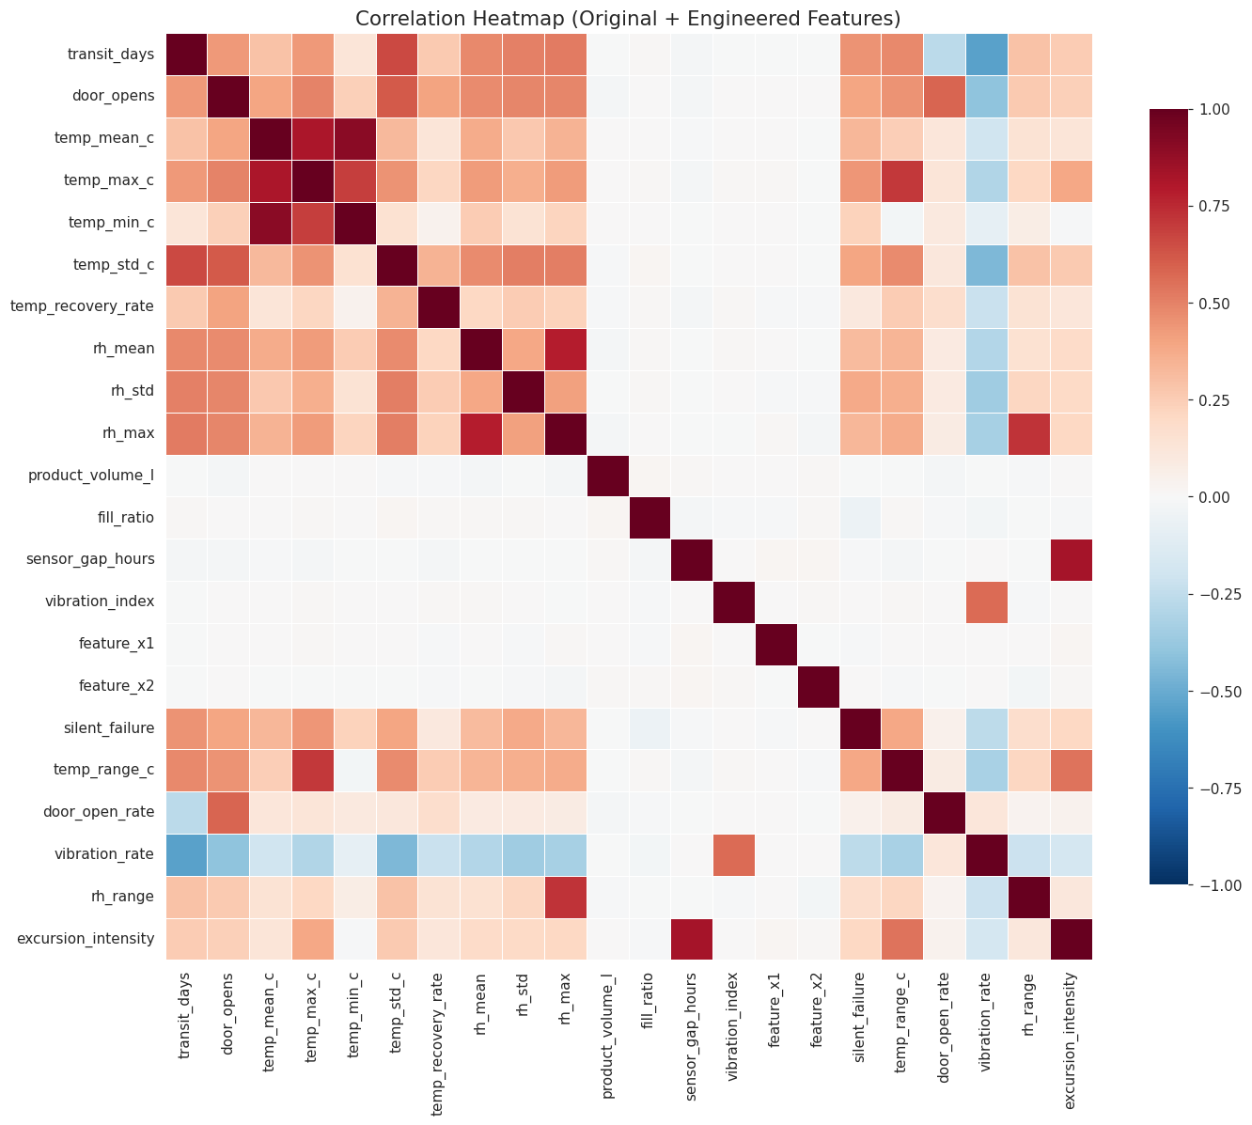
target_corr = corr_matrix["silent_failure"].drop("silent_failure").sort_values(ascending=False)
fig, ax = plt.subplots(figsize=(8, 9))
colors = ["#C0524D" if v >= 0 else "#3E6E8E" for v in target_corr.values]
ax.barh(target_corr.index[::-1], target_corr.values[::-1], color=colors[::-1])
ax.axvline(0, color="black", linewidth=0.8)
ax.set_xlabel("Pearson correlation")
ax.set_title("Feature Correlation with silent_failure")
plt.tight_layout()
plt.savefig("figures/07_target_correlation.png", bbox_inches="tight")
plt.show()
target_corr.round(3).to_frame("pearson_r")
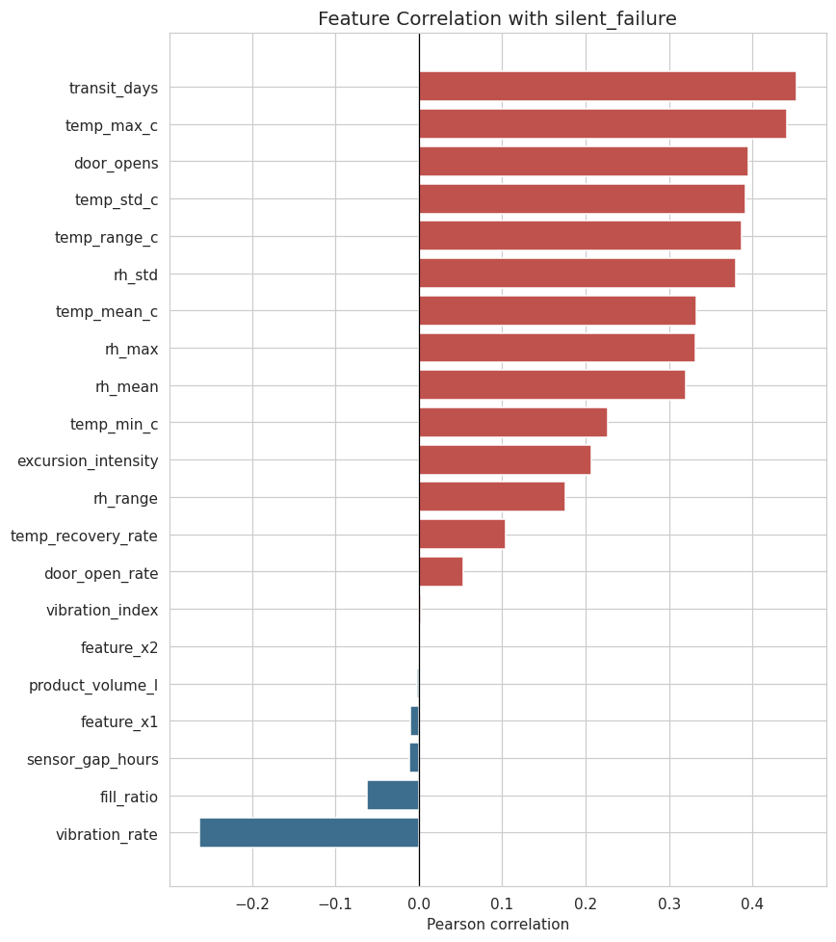
pearson_r
transit_days 0.453
temp_max_c 0.441
door_opens 0.395
temp_std_c 0.392
temp_range_c 0.387
rh_std 0.380
temp_mean_c 0.333
rh_max 0.332
rh_mean 0.319
temp_min_c 0.227
excursion_intensity 0.207
rh_range 0.176
temp_recovery_rate 0.104
door_open_rate 0.053
vibration_index 0.003
feature_x2 0.000
product_volume_l -0.002
feature_x1 -0.011
sensor_gap_hours -0.012
fill_ratio -0.062
vibration_rate -0.263
Note: Temperature stats (mean/max/min/std) and humidity stats (mean/std/max) each form a multicollinear cluster. Top target correlates: transit_days (0.45), temp_max_c (0.44), door_opens (0.39), temp_std_c/temp_range_c (0.39). Routing IDs and anonymized features are ~uncorrelated.

13. Engineered Feature Distributions by Target
fig, axes = plt.subplots(1, 2, figsize=(13, 5))
for label, color in zip([0, 1], PALETTE):
sns.kdeplot(eng.loc[eng.silent_failure == label, "temp_range_c"],
ax=axes[0], fill=True, color=color, label=str(label), alpha=0.5)
axes[0].set_title("Temperature Range Distribution by Target")
axes[0].set_xlabel("temp_range_c")
axes[0].legend(title="silent_failure")
for label, color in zip([0, 1], PALETTE):
sns.kdeplot(eng.loc[eng.silent_failure == label, "vibration_rate"],
ax=axes[1], fill=True, color=color, label=str(label), alpha=0.5)
axes[1].set_title("Vibration Rate Distribution by Target")
axes[1].set_xlabel("vibration_rate")
axes[1].legend(title="silent_failure")
plt.tight_layout()
plt.savefig("figures/08_engineered_features.png", bbox_inches="tight")
plt.show()
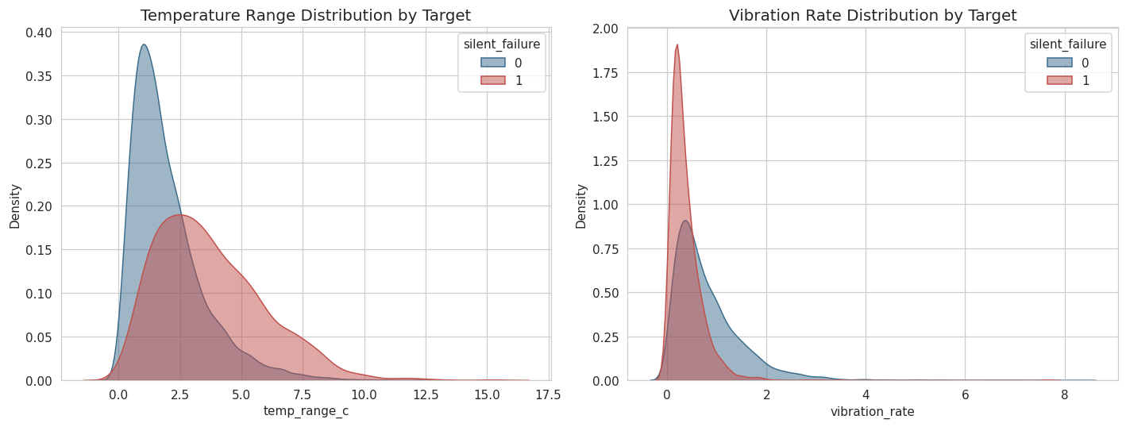
Note: temp_range_c shifts right for failures (wider swings); vibration_rate shifts left for failures (duration artifact, see Section 11).

14. Transit Duration vs. Peak Temperature
fig, ax = plt.subplots(figsize=(7.5, 6))
for label, color, name in zip([0, 1], PALETTE, ["Non-failure", "Silent failure"]):
subset = eng[eng.silent_failure == label]
ax.scatter(subset["transit_days"], subset["temp_max_c"], s=14, alpha=0.5,
color=color, edgecolor="none", label=name)
ax.set_xlabel("transit_days")
ax.set_ylabel("temp_max_c")
ax.set_title("Transit Duration vs. Maximum Temperature")
ax.legend()
plt.tight_layout()
plt.savefig("figures/09_scatter_transit_tempmax.png", bbox_inches="tight")
plt.show()
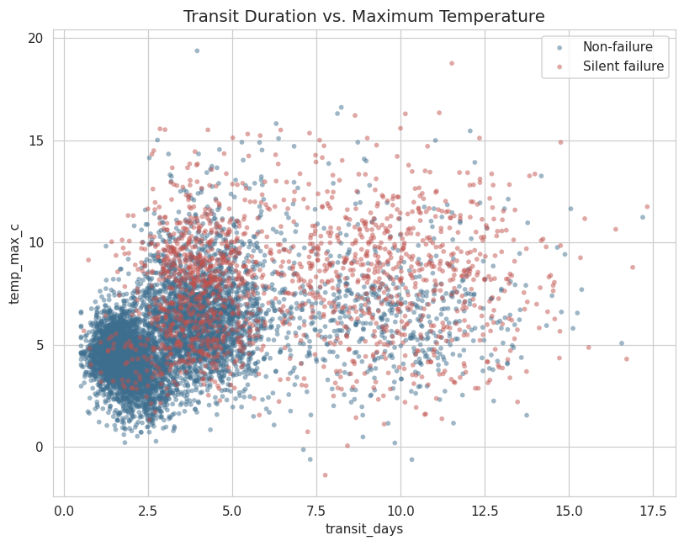
Note: Non-failures cluster tightly at low duration/low peak temp; failures spread toward higher values on both axes — an interaction candidate for modeling.

15. Outlier Detection (IQR Method)
We flag outliers using the classic Tukey IQR rule: a value is flagged if it falls below Q1 - 1.5*IQR or above Q3 + 1.5*IQR.
def iqr_outlier_pct(s):
q1, q3 = s.quantile(0.25), s.quantile(0.75)
iqr = q3 - q1
lo, hi = q1 - 1.5 * iqr, q3 + 1.5 * iqr
return ((s < lo) | (s > hi)).mean() * 100
outlier_cols = ["transit_days", "door_opens", "temp_mean_c", "temp_std_c",
"rh_mean", "sensor_gap_hours", "vibration_index"]
outlier_pcts = pd.Series({c: iqr_outlier_pct(eng[c]) for c in outlier_cols}).round(2)
outlier_pcts = outlier_pcts.sort_values(ascending=False)
outlier_pcts.to_frame("outlier_pct")
outlier_pct
transit_days 9.36
sensor_gap_hours 4.72
temp_mean_c 2.89
rh_mean 1.27
vibration_index 0.84
door_opens 0.69
temp_std_c 0.69
# Do flagged outliers skew toward the failure class?
outlier_failure_link = {}
for c in outlier_cols:
q1, q3 = eng[c].quantile(0.25), eng[c].quantile(0.75)
iqr = q3 - q1
lo, hi = q1 - 1.5 * iqr, q3 + 1.5 * iqr
mask = (eng[c] < lo) | (eng[c] > hi)
outlier_failure_link[c] = eng.loc[mask, "silent_failure"].mean() * 100
pd.Series(outlier_failure_link).round(2).sort_values(ascending=False).to_frame(
"failure_rate_pct_among_outliers")
failure_rate_pct_among_outliers
temp_mean_c 60.17
transit_days 58.48
rh_mean 51.96
door_opens 50.91
temp_std_c 47.27
vibration_index 23.88
sensor_gap_hours 17.20
Note: Outlier rate ranges from 0.69% (door_opens) to 9.36% (transit_days). Failure rate among outliers exceeds the 19.7% base rate for most features, so outliers are kept (winsorized, not dropped)..

